Song: Nothing but flowers (Talking Heads)

Niveau: B1/B2

Topic: Implications of modern life

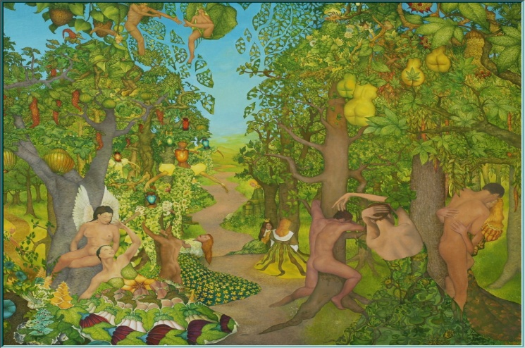

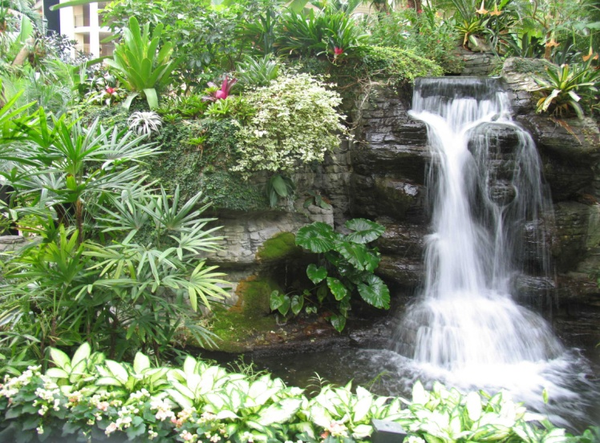

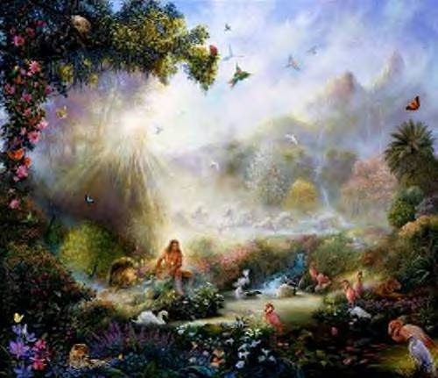

Here we stand  
Like an Adam and an Eve  
Waterfalls  
The Garden of Eden  
Two fools in love  
So beautiful and strong  
The birds in the trees  
Are smiling upon them  
From the age of the dinosaurs  
Cars have run on gasoline  
Where, where have they gone?  
Now, it's nothing but flowers  
  
There was a factory  
Now, there are mountains and rivers  
You got it, you got it  
We caught a rattlesnake  
Now, we got something for dinner  
We got it, we got it  
There was a shopping mall  
Now, it's all covered with flowers  
You've got it, you've got it  
If this is paradise  
I wish I had a lawnmower  
You've got it, you've got it

Years ago  
I was an angry young man  
I'd pretend  
That I was a billboard  
Standing tall  
By the side of the road

[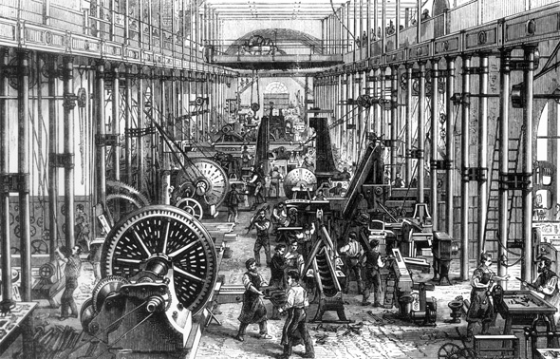](http://www.museumgrenchen.ch/ausstellungen/was-ist-die-industrialisierung/index.html)

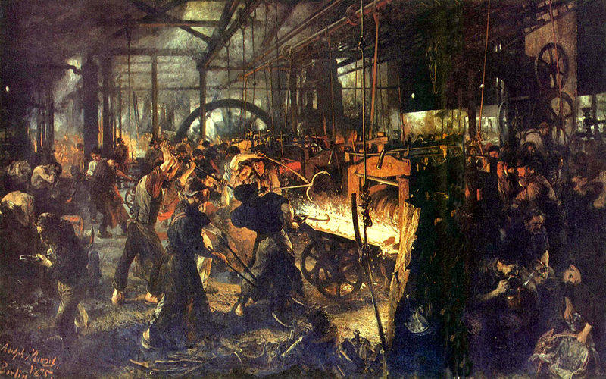

[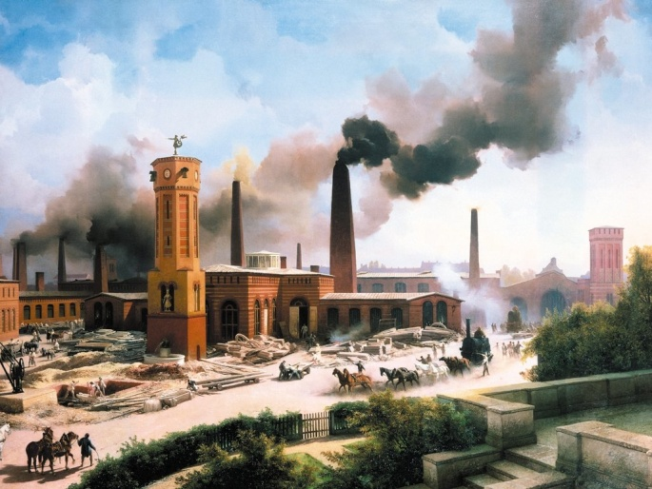](http://www.in-die-zukunft-gedacht.de/de/page/68/epochen-abschnitt/160/dokument/236/epochen.html)

I fell in love  
With a beautiful highway  
This used to be real estate

Now, it´s only fields and trees

Where, where is the town?  
Now, it's nothing but flowers

The highways and cars  
Were sacrificed for agriculture  
I thought that we'd start over  
But I guess I was wrong, hey  
  
Once there were parking lots  
Now, it's a peaceful oasis  
You got it, you got it  
This was a Pizza Hut  
Now, it's all covered with daisies  
You got it, you got it  
I miss the honky tonks  
Dairy Queens and 7-Elevens  
You got it, you got it  
And as things fell apart  
Nobody paid much attention  
You got it, you got it  
  
I dream of cherry pies  
Candy bars and chocolate chip cookies  
You got it, you got it  
We used to microwave  
Now, we just eat nuts and berries  
You got it, you got it  
This was a discount store  
Now, it's turned into a cornfield  
You got it, you got it  
Don't leave me stranded here  
I can't get used to this lifestyle