I heard that you're settled down  
That you found a girl  
And you're married now  
I heard that your dreams came true  
Guess she gave you things  
I didn't give to you  
Old friend why are you so shy  
Ain't like you to hold back  
Or hide from the light  
  
I hate to turn up out of the blue uninvited but  
I couldn't stay away I couldn't fight it  
I had hoped you'd see my face  
And that you'd be reminded that for me it isn't over  
  
Never mind I'll find someone like you  
I wish nothing but the best for you two  
Don't forget me I beg I'll remember you said  
Sometimes it lasts in love but sometimes it hurts instead  
Sometimes it lasts in love but sometimes it hurts instead, yeah  
  
You know how the time flies  
Only yesterday was the time of our lives  
We were born and raised  
In a summer haze  
Bound by the surprise of our glory days  
  
I hate to turn up out of the blue uninvited but  
I couldn't stay away I couldn't fight it  
I had hoped you'd see my face  
And that you'd be reminded that for me it isn't over  
  
Never mind I find someone like you  
I wish nothing but the best for you two  
Don't forget me I beg I'll remember you said  
Sometimes it lasts in love but sometimes it hurts instead  
  
Nothing compares  
No worries or cares  
Regrets and mistakes they're memories made  
Who would have known how bitter-sweet this would taste  
  
  
Never mind how I'll find someone like you  
I wish nothing but the best for you two  
Don't forget me I beg I'll remember you said  
Sometimes it lasts in love but sometimes it hurts instead  
Sometimes it lasts in love but sometimes it hurts instead, yeah

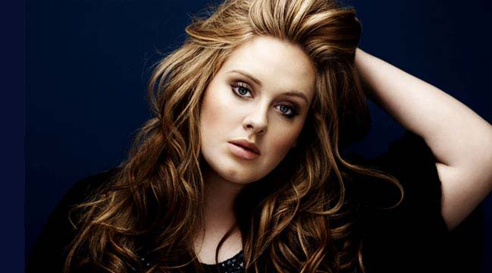[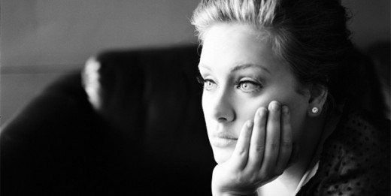](http://blog.cellep.com/wp-content/uploads/2012/01/Adele-SomeoneLikeYou-608_w608.jpg)



