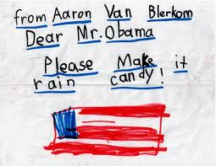

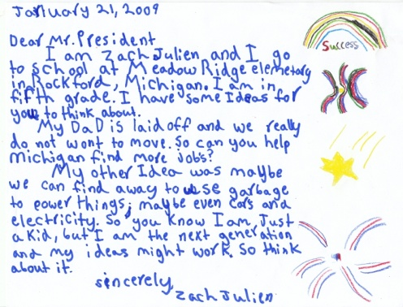

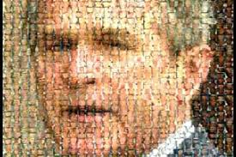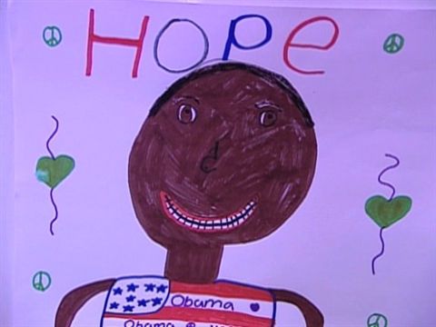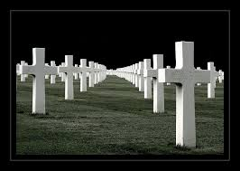

Dear Mr. President,   
 Come take a walk with me.   
 Let's pretend we're just two people and   
 You're not better than me.   
5 I'd like to ask you some questions if we can speak honestly.   
  
 What do you feel when you see all the homeless on the street?   
 Who do you pray for at night before you go to sleep?   
 What do you feel when you look in the mirror?   
 Are you proud?   
  
10 How do you sleep while the rest of us cry?   
 How do you dream when a mother has no chance to say goodbye?   
 How do you walk with your head held high?   
 Can you even look me in the eye   
 And tell me why?   
  
15 Dear Mr. President,   
 Were you a lonely boy?   
 Are you a lonely boy?   
 Are you a lonely boy?   
 How can you say   
 No child is left behind?   
20 We're not dumb and we're not blind.   
 They're all sitting in your cells   
 While you pave the road to hell.   
  
 What kind of father would take his own daughter's rights away?   
 And what kind of father might hate his own daughter if she were gay?   
25 I can only imagine what the first lady has to say   
 You've come a long way from whiskey and cocaine.   
   
 How do you sleep while the rest of us cry?   
 How do you dream when a mother has no chance to say goodbye?   
 How do you walk with your head held high?   
30 Can you even look me in the eye?   
  
 Let me tell you 'bout hard work   
 Minimum wage with a baby on the way   
 Let me tell you 'bout hard work   
 Rebuilding your house after the bombs took them away   
35 Let me tell you 'bout hard work   
 Building a bed out of a cardboard box   
 Let me tell you 'bout hard work   
 Hard work   
 Hard work   
40 You don't know nothing 'bout hard work   
 Hard work   
 Hard work   
 Oh   
  
 How do you sleep at night?   
45 How do you walk with your head held high?   
 Dear Mr. President,   
 You'd never take a walk with me.   
 Would you?