***A CHORAL SONG, preliminary questionnaire***

We are 10 participating countries in the project: *Spain, Portugal, Belgium, Slovakia, Germany, Greece, France, Romania, Poland and Turkey. We will now try to find out what you already know about these countries.*

***GEOGRAPHICAL PART***

1. ***Write the names of the countries into their places on the map***

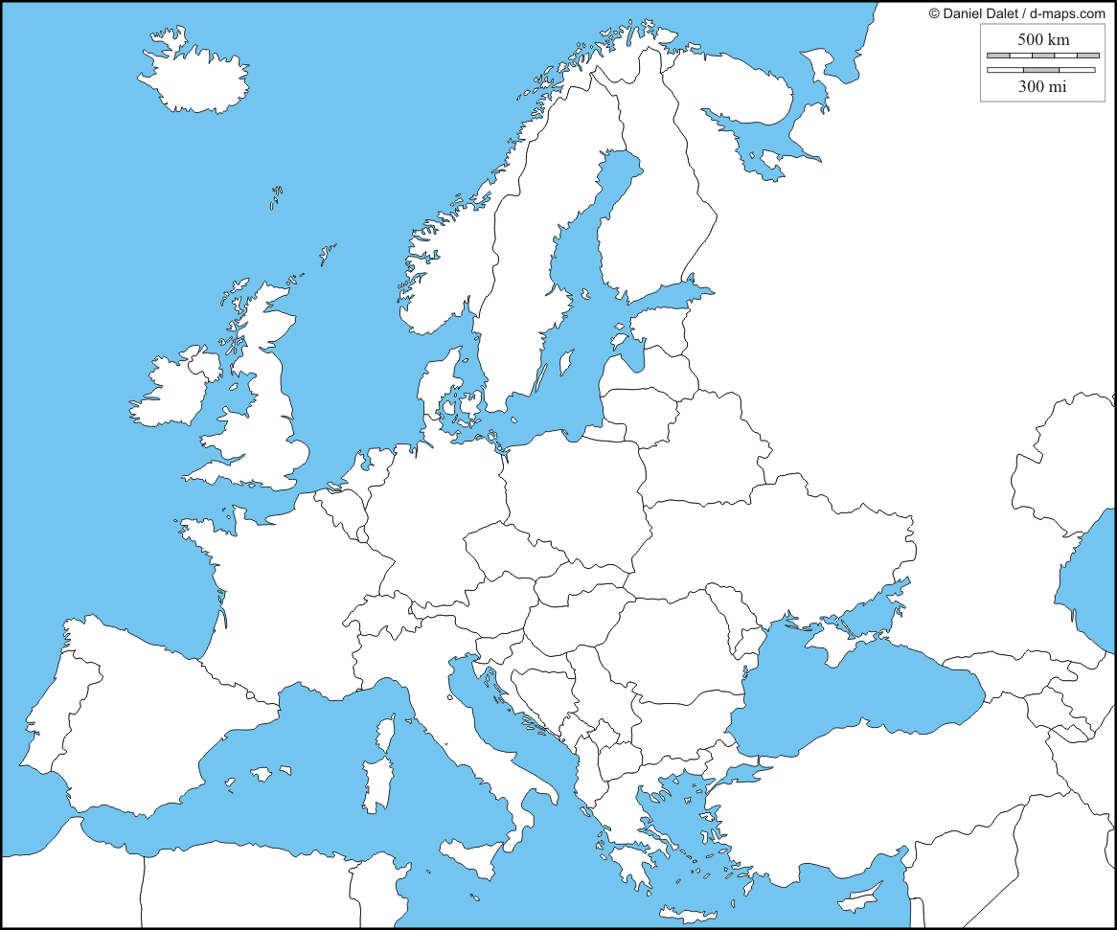

1. ***Match the countries and their capitals***

Berlin

Spain

Bratislava

Portugal

Paris

Turkey

Bucharest

Slovakia

Istanbul

Germany

Warsaw

Greece

Madrid

France

Athens

Romania

Lisbon

Poland

1. ***Write the names of the countries into their correct boxes .***

|  |  |
| --- | --- |
| ***Member of the European Union*** | ***No member of the European Union*** |
|  |  |

***4. Which of these buildings is to be found in the participating countries? Where?.***

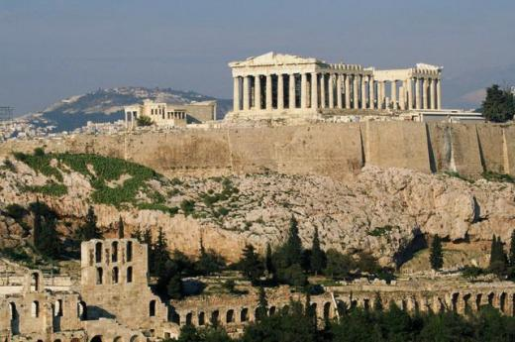

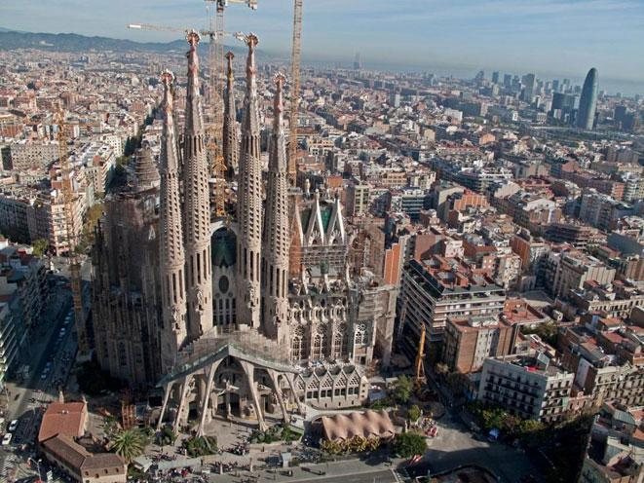

***Which of these buildings belongs to.***

……………………………………………………………. ………………………………………………………..

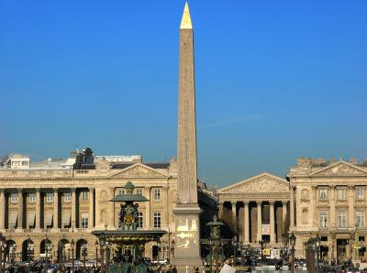

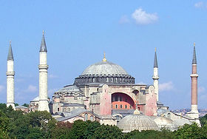

………………………………………………………….. ………………………………………………………….

……………………………………………………………. ……………………………………………………...

***5. What are the countries adjacent to the Mediterranean ?***

…………………………………………………………………………………………………………………………………………………………

***6. When you go on holiday, in which of the participating countries do you have to exchange your euros for the local currency ?***

…………………………………………………………………………………………………………………………………………………………………………………………………………………………………………………………………………………………………………………………

***7. In which country is the highest mountain in Europe?*** ……………………………………………………

***8. Except for Luxembourg, which other countries house institutions of the European Union?*** ………………………….. and ………………………………..

***9. Is Belgium a republic or a monarchy?*** …………………………………….

***10. Write down the names of three partner countries which have got the highest population density in Europe.***

………………………………………………………………………………………………………………………………………………………

***HISTORICAL PART:***

1. ***Who is the person responsible for the foundation of the secular state of Turkey after the end of the First World War?***

* [Cheikh Saïd](http://fr.wikipedia.org/wiki/Cheikh_Sa%C3%AFd_(Turquie))
* [Turgut Özal](http://fr.wikipedia.org/wiki/Turgut_%C3%96zal)
* [Mustafa Kemal](http://fr.wikipedia.org/wiki/Mustafa_Kemal)

1. ***Before it became independent, to which Empire did Turkey use to belong?***

* The Holy Roman Empire
* The Roman Ottoman Empire

The Roman Occidental Empire

1. ***What does GDR and FRG mean?***

……………………………………………………………………………………………………………………………………………….

1. ***Who is this person and what do you know about him?***

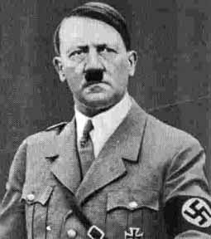

………………………………………………………………………………………………………………………………………………………………………………………………………………………………………………………………………………………………………………………………………………………………………………………………

1. ***The following events belong to the Second World War. Place them on the time line in the correct chronological order.***

*Attack on Pearl Harbour (Hawaï,United States) – Poland invaded by German troups –the day of the Normandy landings –first nuclear bomb thrown on Hiroshima (Japan) – Hitler breaks the German-Soviet Non-Agression Treaty.*

1. ***Before it became independant, which country did Belgium belong to ?***

* Austria
* Spain
* England
* The Netherlands

1. ***Which of these countries used to be an important Belgian colony?***

* Kenia
* Algeria
* Congo

1. ***Match these famous personnalities that have been important in Spanish history to the corresponding descriptions:***

* Archduke of Austria and Prince of Spain, ([1500](http://fr.wikipedia.org/wiki/1500)-[1558](http://fr.wikipedia.org/wiki/1558)) of the House ofHabsburg, regarded as the most important and powerful Christian monarch of his time.
* artist, painter and sculptor regarded as the founder of cubism.
* géneral and head of state (1892-1975), established his authoritarian and dictatorial government under the title of [*Caudillo*](http://fr.wikipedia.org/wiki/Caudillo).
* [italian](http://fr.wikipedia.org/wiki/Italie) explorer and navigator (1451-1506) who with the support of the Catholic Spanish monarchs Isabella I of Castile and Ferdinand II of Aragon was the first European to reach the American continent.
* Christopher Colombus
* Picasso
* Fransisco Franco
* Charles Quint

1. ***Which country was Slovakia politically linked to before it became independent in 1993?***

* Austria
* Hungary
* The Czech Republic

1. ***Which political system established itself in Slovakia after the coup in Prague in 1948 ?***

* Communism
* nazism

federalism

1. ***Which discovery is attributed to the Portugese navigator Vasco da Gama? Write his name next to the correct route into the map!***

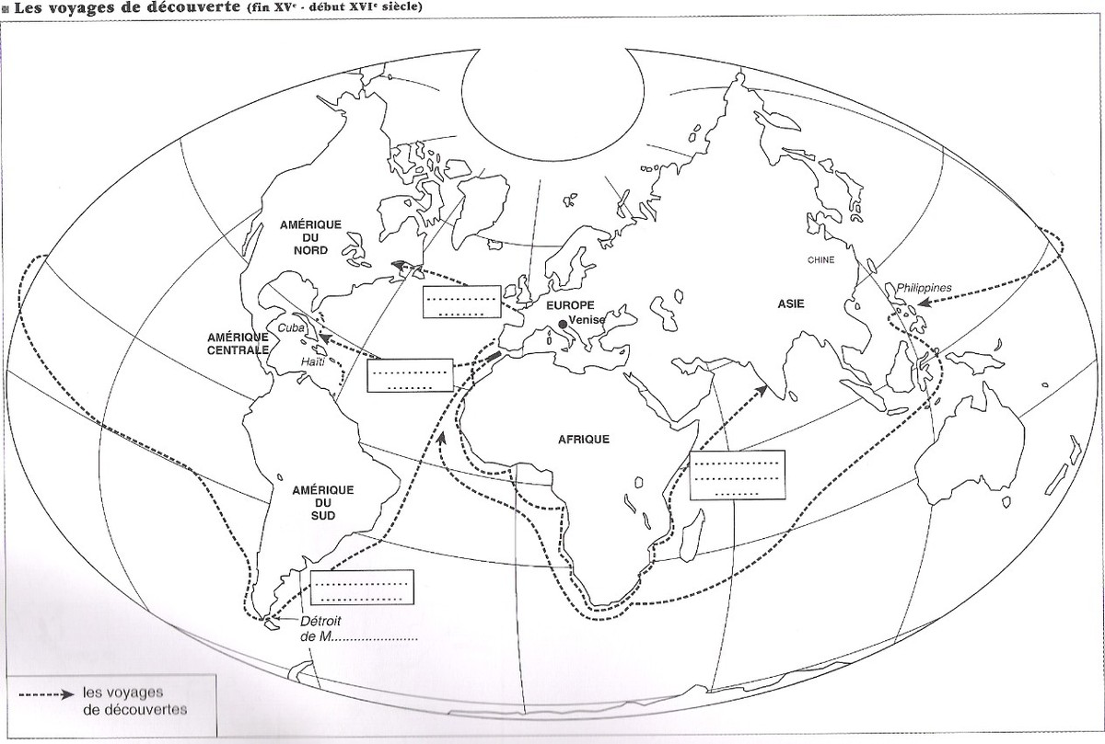

1. ***Quel pays du continent américain fut longtemps une colonie portugaise ?***

* La Colombie
* Le Mexique
* Le Brésil

1. ***Who was Nicolae Ceaușescu ?***

* Leader of the Communist Government in Romania
* Former dictator and Head of State in Romania
* Member of the Soviet Government under Gorbatchev

1. ***In which year did Romania become a member of the European Union?***

* 1995
* 2004
* 2007

1. ***Who are these famous Greeks and to which field of science do they belong? Match the personnalities to their domains.***

* Herodotus
* Mathematician
* Scientist
* Historian
* Philosopher
* Artiste
* Platon
* Pythagoras
* Aristotle
* Hippocrates
* Archimedes
* Euclid
* Socrates
* Thales
* Phidias

1. ***These are columns of Greek temples. Match the columns to the different architectural styles in the pictures.***

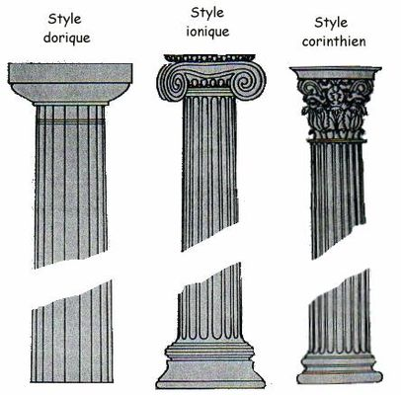

Ionic style : ……………

Corinthian style : …………….

Doric style : ……………

1. ***Which important event in French history took place in 1789 ?***

* The French Revolution and the abolition of monarchy
* the crowning of Louis XIV
* King Henry IV is assassinated by Ravaillac

1. ***Who is this famous person? What do you know about him?***

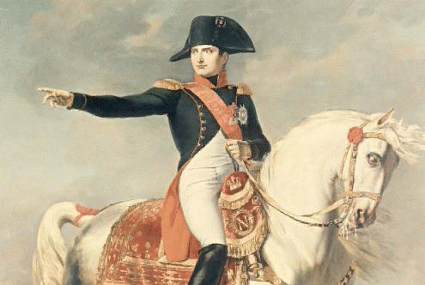

***What ideas do we have of the others?***

1. Belgium is a country where…
2. The Belgians are…
3. The Belgians love…
4. The most famous Belgian is…
5. Do all Belgian people speak French ?
6. Is it true that Flemings and Walloons don`t like each other ?
7. What is the name of the Belgian Prime Minister ?
8. Is Belgium a kingdom ?
9. Are all the Belgians Catholics ?
10. What do most people say about the Belgians ?
11. I think Poland is a country where…
12. I think Polish people are …
13. Is it true that Polish people are fervent Catholics?
14. What do most people say about the Polish?
15. What is the dish Polish people like best?
16. Do people speak more than one language in Poland?
17. Which is the best known monument in Poland ?
18. When I say Turkish, I think of….
19. Do all the Turks have a moustache ?
20. The Turkish religion is…
21. What do you know about the Turkish culture ?
22. In Turkey people speak …
23. Why do people always mention Ataturk when talking about Turkey ?
24. Are the Turks Orientals or Occidentals?
25. Romania is a country where…
26. Can you name a famous Romanian personality ?
27. Was Dracula really Romanian ?
28. The Romanians are…
29. The Roms (gypsies) are…
30. What do you imagine about Romania ?
31. A Frenchman is a person who…
32. Do the French always wear berets ?
33. When you think of France, you think of…?
34. Where ( in what context) do you often hear about France ?
35. Who is the best known French person ?
36. Is it true that all French persons speak the same language ?
37. In France people eat…
38. Is it true that all Germans are serious and conscientious ?
39. In Germany people are…
40. What is the capital of Germany ?
41. Are all German people blond ?
42. Why is Germany often called the " European locomotive"  ?
43. What is the first thing that comes into my head talking about Germany?
44. German is a language that…
45. In Spain people are…
46. How would you describe a Spaniard ?
47. Three things that come into your mind talking about Spain ?
48. Has Spain always been a monarchy?
49. Do the Spaniards really speak like cows ?
50. Where is Slovakia situated ?
51. In Slovakia people are…
52. What are the Slovakian people like ?
53. Who is the most famous representative of their culture?
54. Are the Czechs and the Slovakians brothers?
55. I think Slovakia is a country where…
56. What do people know best about the Greek?
57. Who is the best known Greek personality?
58. What is the most popular dish in Greece?
59. Are all the Greeks Hellenic?
60. Why has the Greek language so strongly influenced other national languages?
61. To go to Greece means…
62. Greece is a country where…
63. The Portuguese are known for…
64. Is Portugal like Spain ?
65. When Portugal is mentioned, what comes into your mind?
66. Do people in Portugal speak Portuguese?
67. Is it true that the Portuguese are very religious people?